We develop the Linear regression

RSE

R-squared

X y

1. 1
2. 4
3. 9 ============== > yp=x/2*x

Again will pass the train data to the model x=1 ==== yp=1/2*1=0.5 vs y=1

X=2 ==== yp=4 vs y=4

Model will develop by pass both train input and train output data

You will pass the train input data to the model, and you compare those predictions with train output ============= train error

You will pass the test input data to the model, and you compare those predictions with test output ============ test error

If your model trained very well on train data ======= train error will be very less (we need this)

If your model not trained very well on train data ===== train error will be high ( Underfit)

Assume that

Your train error is low ======== very happy

Now I will pass test input data , I will compare with test output with model predictions

============== Test error

Case-1) Test error might be low train error low and test error low ====== Normal fit

Case-2) test error might be high train error low and test error high ====== Overfit

Overfit means model very well trained on train data, but when I pass test data

It is giving unusual result

5Qns and 5 ans ======== I given to you ======= Byhearted 5/5

6qns ================= SALAR STORY ======= -100

| Underfit | Train error high |
| --- | --- |
| Normal fit | Train error and Test error both are low |
| Overfit | Train error low and Test error high |

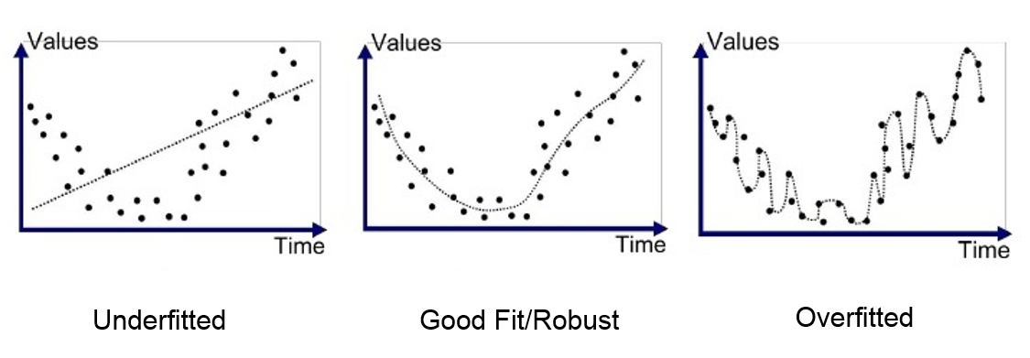

Overfit happens because of less data

Overfit ===== Not able to learn patterns

Overfit happens because of usage of all the variables



      
      
      
      